In the Name of God



Navid Zare

40435071

Statistical Pattern Recognition
Bonus Section: Regularized Linear Regression with SGD

1. Introduction and Methodology

1.1 Objective
The objective of this bonus section is to extend the linear regression implementation by incorporating Ridge Regression (L2 regularization) trained using Stochastic Gradient Descent (SGD). This analysis aims to:
• Analyze multicollinearity in the feature set using correlation analysis and VIF
• Implement Ridge Regression with SGD for multiple regularization parameters
• Compare model stability and performance across different λ values
• Analyze the bias-variance tradeoff in regularized linear models

1.2 Dataset Description
The Auto MPG dataset contains 392 samples with three input features (weight, horsepower, displacement) and one target variable (mpg - miles per gallon). The data was split into training (314 samples, 80%) and testing (78 samples, 20%) sets using random_state=42.
Feature | Mean | Std Dev | Description
weight | 2977.58 | 848.32 | Vehicle weight in lbs
horsepower | 104.47 | 38.44 | Engine power
displacement | 194.41 | 104.51 | Engine displacement
mpg | 23.45 | 7.81 | Fuel efficiency (target)

1.3 Mathematical Foundations

1.3.1 Linear Regression Model
The linear regression model with multiple features is defined as:
$h\left(x\right)=θ_{0}+θ_{1}x_{1}+θ_{2}x_{2}+…+θ_{n}x_{n}=θ^{⊤}X$
where θ₀ is the bias term and θ₁, θ₂, ..., θₙ are the feature coefficients.

1.3.2 Ridge Regression (L2 Regularization)
Ridge Regression adds an L2 penalty term to the standard MSE cost function:
$$J\left(θ\right)=\frac{1}{2n}\sum{{\left(h\left(x_{i}\right)-y_{i}\right)}^{2}}+\frac{λ}{2}\sum{θ_{j}^{2}}$$
where λ is the regularization parameter and the sum over θⱼ excludes the bias term (θ₀).

1.3.3 SGD Update Rules for Ridge Regression
The gradient descent update rules with L2 regularization are:
For the bias term (no regularization):
$$θ_{0}≔θ_{0}-α×\left(h\left(x_{i}\right)-y_{i}\right)$$
For feature coefficients (with regularization):
$θ_{j}≔θ_{j}-α×\left(\left(h\left(x_{i}\right)-y_{i}\right)×x_{ij}+λ×θ_{j}\right)$

1.3.4 Variance Inflation Factor (VIF)
VIF measures multicollinearity by quantifying how much the variance of an estimated coefficient increases due to collinearity:
$${\text{VIF}}_{j}=\frac{1}{1-R_{j}^{2}}$$
where Rⱼ² is the coefficient of determination when regressing feature j on all other features.

2. Multicollinearity Analysis

2.1 Correlation Matrix Analysis
The correlation matrix reveals the pairwise linear relationships between all input features. High correlation values (|r| > 0.7) indicate potential multicollinearity issues.
Feature Pair | Correlation (r) | Interpretation
weight ↔ horsepower | 0.8559 | Strong positive correlation
weight ↔ displacement | 0.9276 | Very strong positive correlation
horsepower ↔ displacement | 0.8928 | Strong positive correlation
Key Finding: All three feature pairs exhibit correlation coefficients above 0.7, indicating significant multicollinearity in the dataset. The strongest correlation (r = 0.9276) exists between weight and displacement.
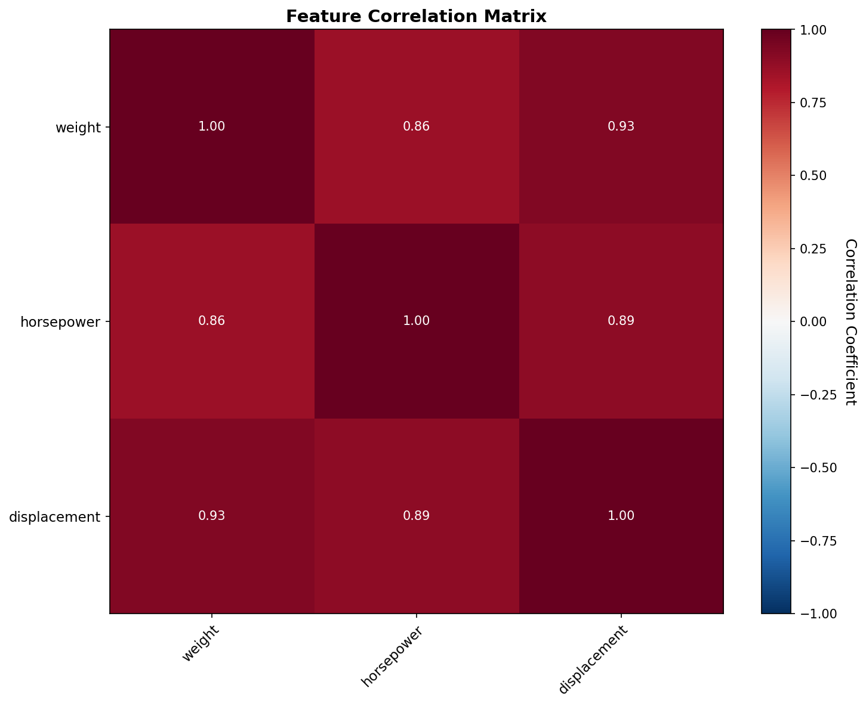
Figure 1: Feature Correlation Matrix Heatmap

2.2 Variance Inflation Factor (VIF) Analysis
VIF values quantify the severity of multicollinearity for each feature. Values above 5 indicate concerning levels, while values above 10 suggest severe multicollinearity.

Feature | VIF Value | Interpretation | Assessment
weight | 7.36 | High (5 < VIF < 10) | Concerning
horsepower | 5.07 | High (5 < VIF < 10) | Concerning
displacement | 9.70 | High (5 < VIF < 10) | Concerning
Key Finding: All features exhibit VIF values above 5, confirming significant multicollinearity. Displacement has the highest VIF (9.70), indicating it shares substantial variance with other predictors. This justifies the application of Ridge Regression to stabilize coefficient estimates.
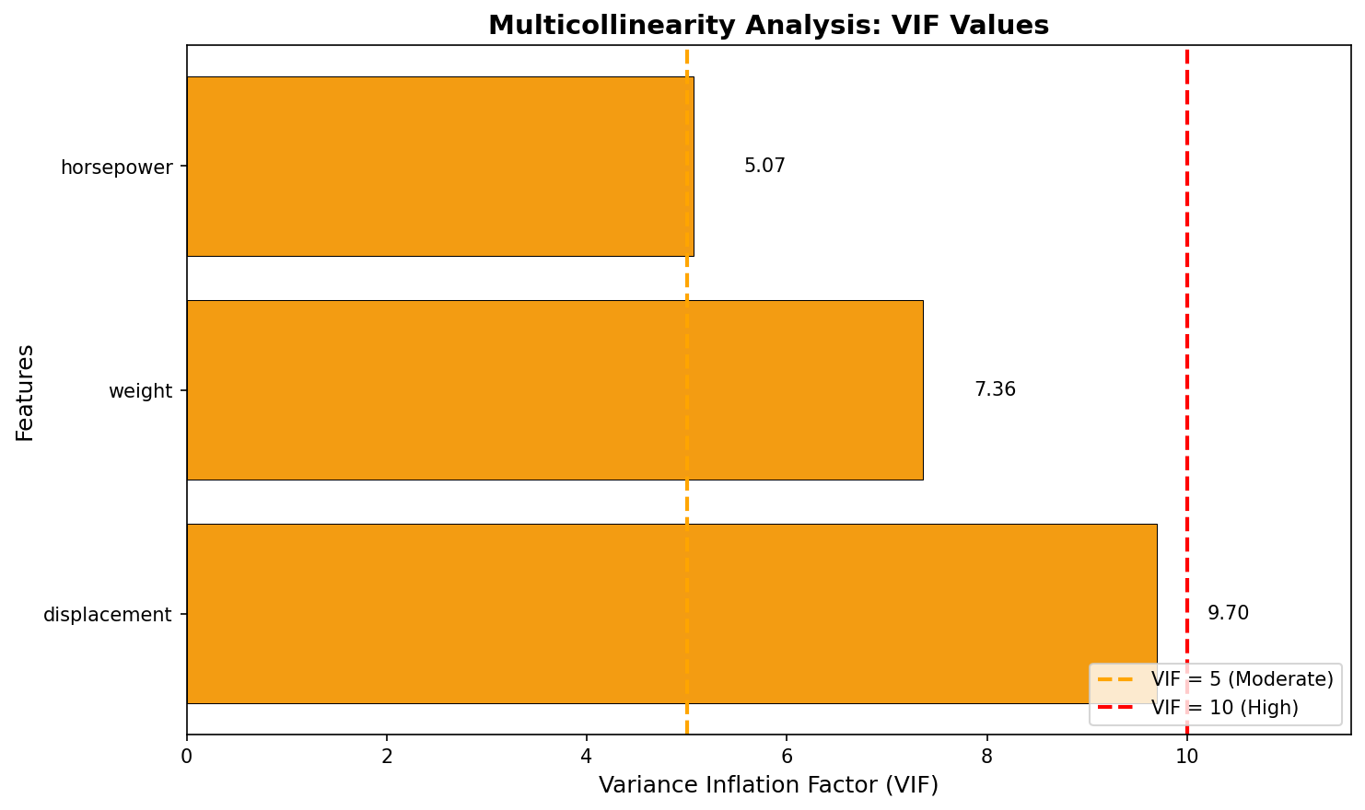
Figure 2: Variance Inflation Factor (VIF) Analysis

3. Ridge Regression with SGD Results

3.1 Hyperparameters
The following hyperparameters were used for all Ridge Regression experiments:
Hyperparameter | Value | Description
Learning Rate (α) | 0.01 | Step size for gradient updates
Number of Epochs | 200 | Complete passes through training data
Regularization (λ) | 0, 0.01, 0.1, 1 | L2 penalty strength values tested
Random State | 42 | For reproducibility

3.2 Learned Coefficients
The table below shows the learned model parameters for each regularization strength:
λ | θ₀ (bias) | θ_weight | θ_horsepower | θ_displacement
0.00 | 23.5569 | -4.2992 | -1.4767 | -0.8004
0.01 | 23.5519 | -4.0760 | -1.4702 | -1.0018
0.10 | 23.5317 | -3.1424 | -1.5166 | -1.6700
1.00 | 23.5098 | -1.8436 | -1.3208 | -1.6137
Observations: As λ increases, coefficient magnitudes generally decrease (shrinkage effect). The bias term remains relatively stable across all λ values. The weight coefficient shows the most dramatic shrinkage, from -4.2992 (λ=0) to -1.8436 (λ=1), a reduction of 57%.
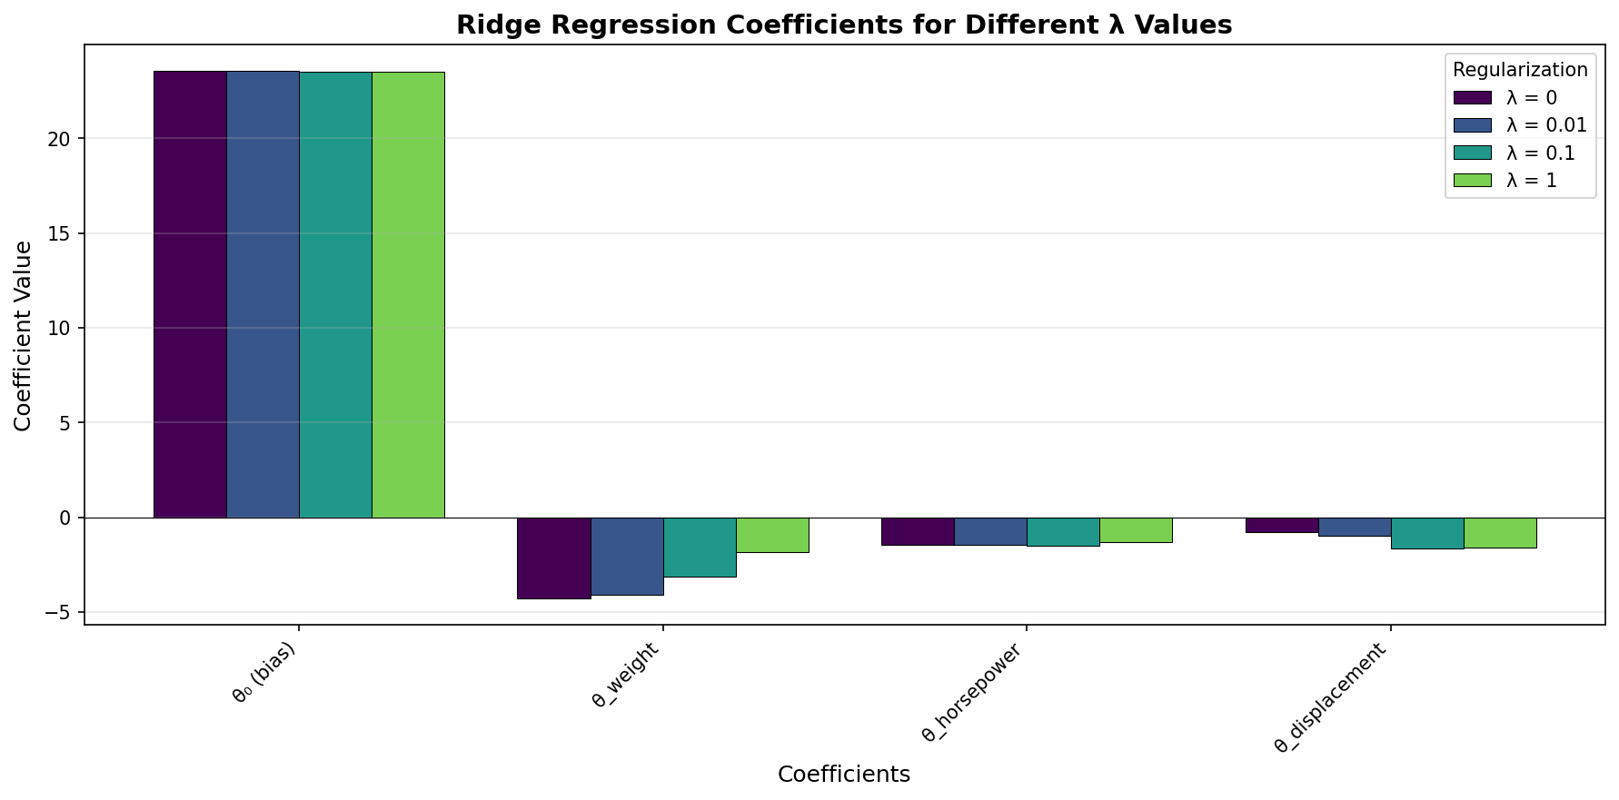
Figure 3: Ridge Regression Coefficients for Different λ Values

3.3 Training and Testing Performance
The Mean Squared Error (MSE) values for training and testing sets across all λ values:
λ | Training MSE | Testing MSE | Generalization Gap
0.00 | 8.992443 | 8.639029 | -0.353414
0.01 | 9.003509 | 8.646744 | -0.356764
0.10 | 9.170811 | 8.656173 | -0.514638
1.00 | 11.288157 | 9.200484 | -2.087674
Key Finding: The unregularized model (λ = 0) achieves the best test MSE (8.639029). The negative generalization gap indicates the model generalizes well. As λ increases, both training and test MSE increase, with the gap widening significantly for λ = 1.
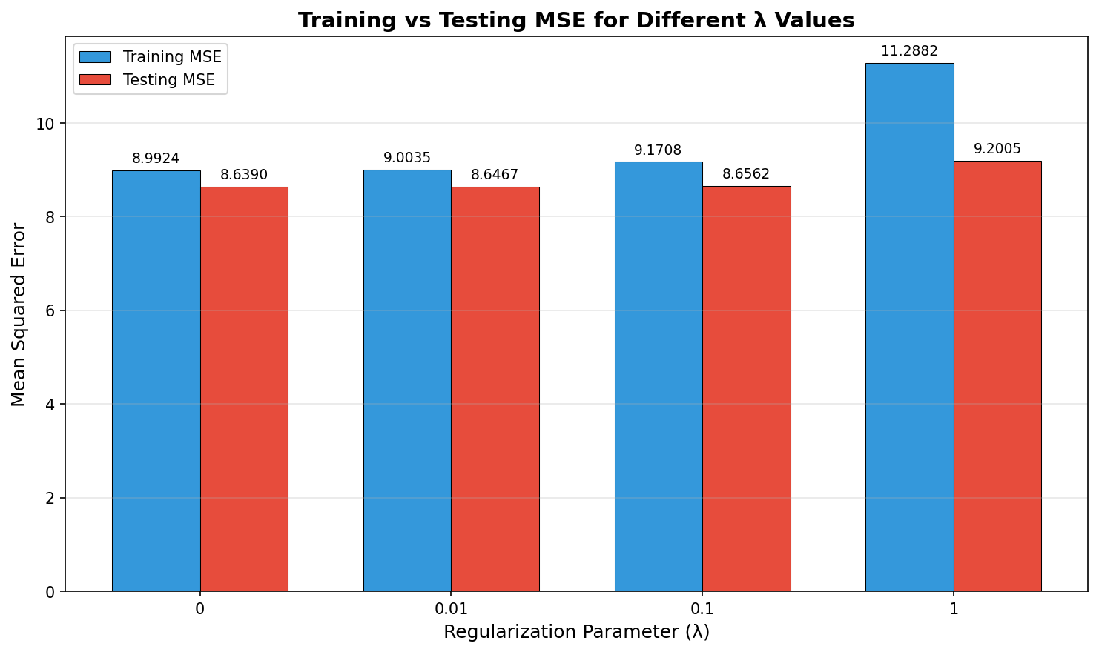
Figure 4: Training vs Testing MSE for Different λ Values

4. Convergence Analysis

4.1 SGD Training Convergence
The convergence behavior of SGD for each regularization parameter is analyzed below:
λ | Initial MSE | Final MSE | Min MSE | Convergence Epoch | Reduction %
0.00 | 9.6866 | 8.9924 | 8.9333 | 140 | 7.17%
0.01 | 9.6946 | 9.0035 | 8.9355 | 57 | 7.13%
0.1 | 9.7835 | 9.1708 | 9.0002 | 61 | 6.26%
1.00 | 11.4901 | 11.2882 | 9.5834 | 2 | 1.76%
Observations: Lower λ values show smoother convergence with greater cost reduction. Higher λ values converge faster (earlier epochs) but to higher final costs. The λ = 1 case shows minimal improvement (1.76% reduction), indicating the regularization penalty dominates the optimization.
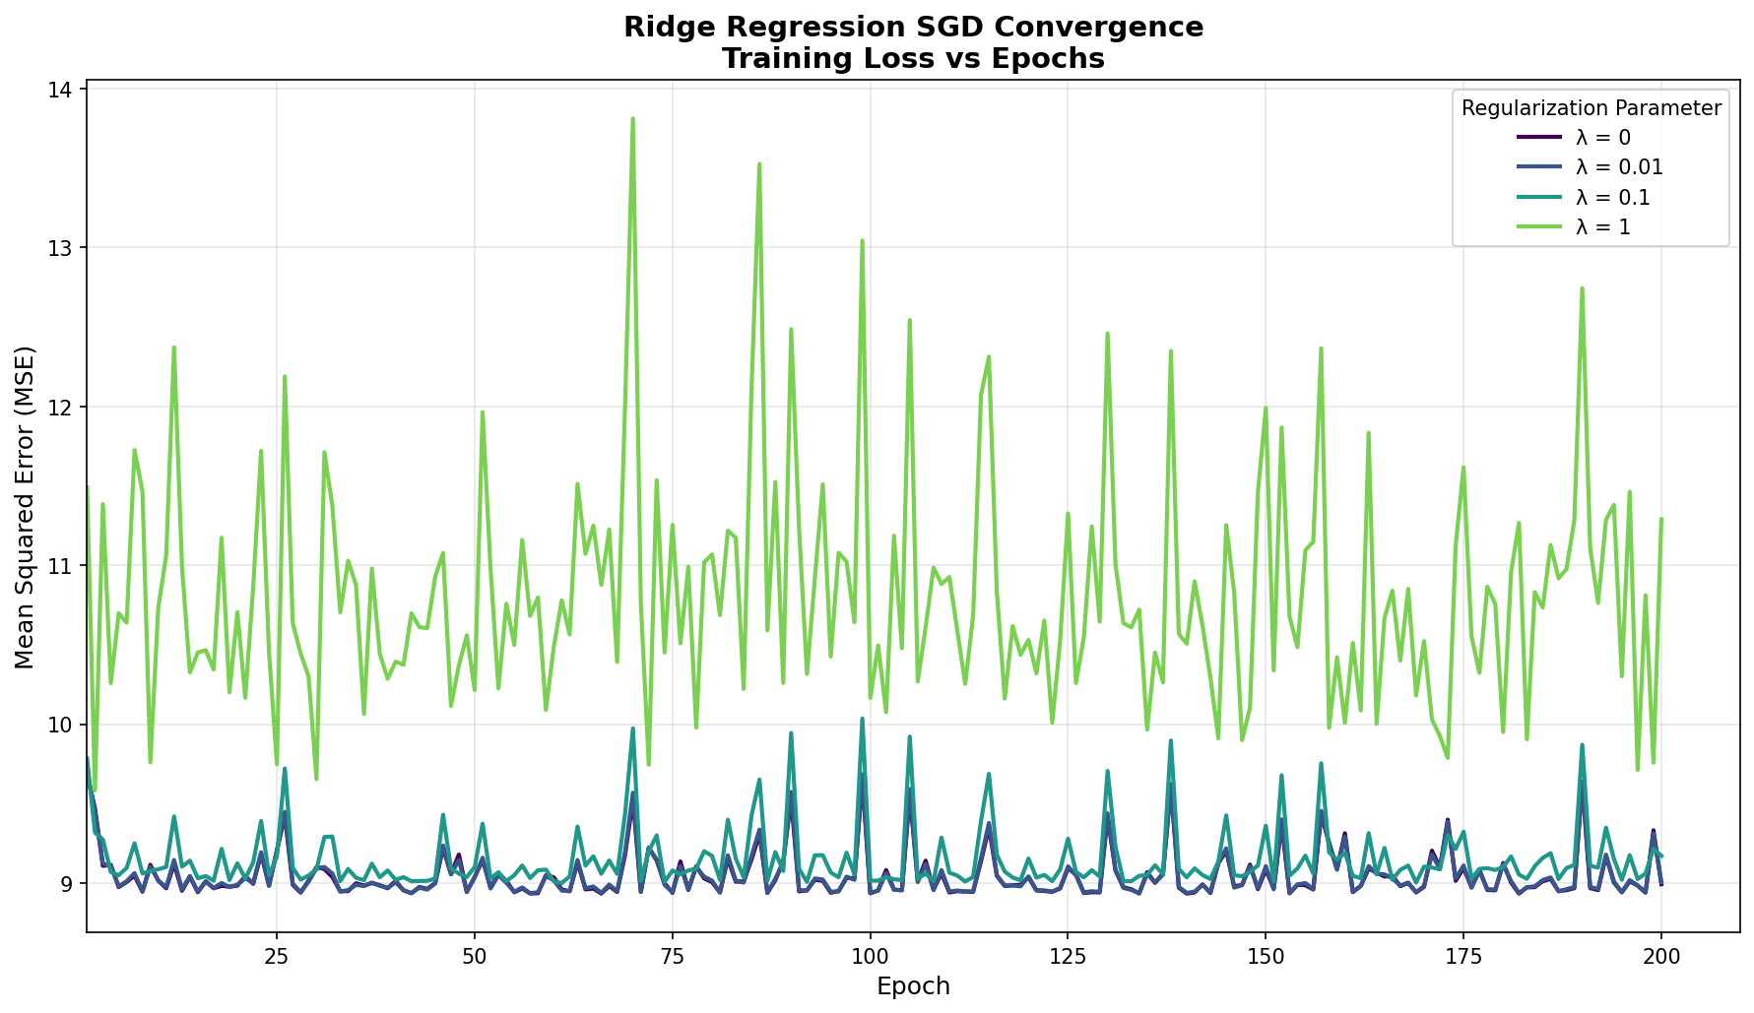
Figure 5: Ridge Regression SGD Convergence - Training Loss vs Epochs
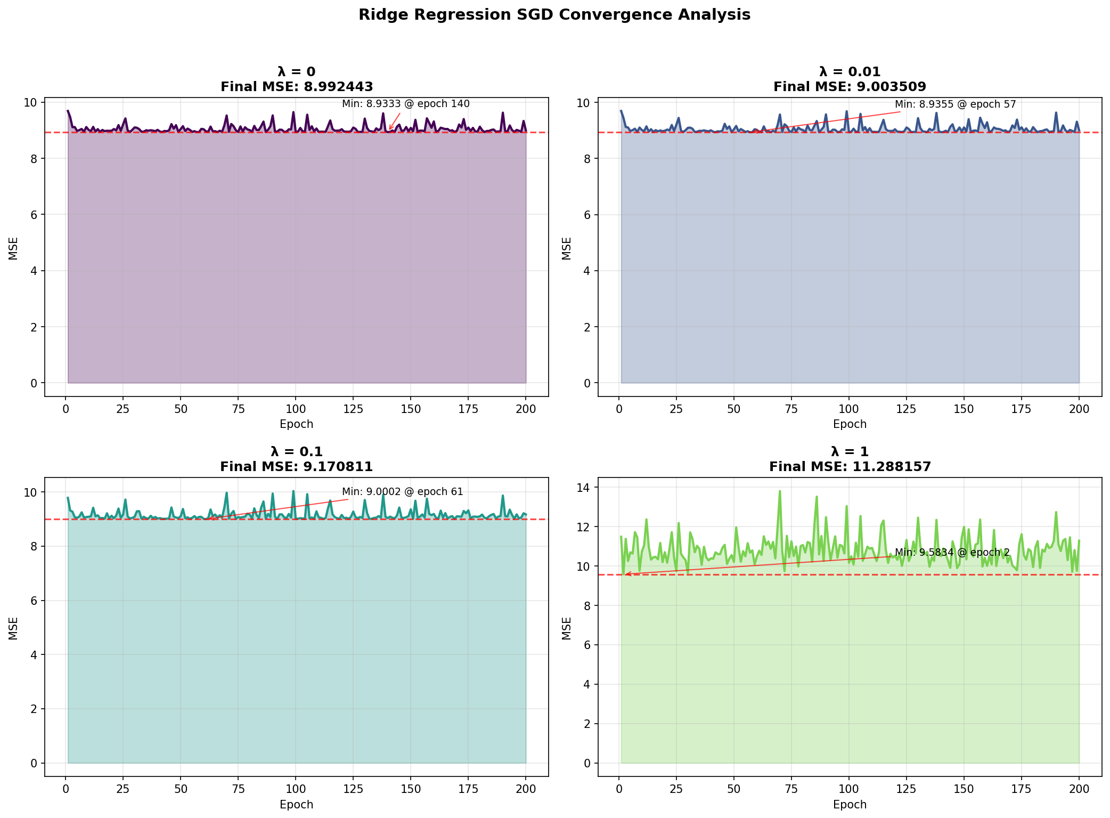
Figure 6: Detailed Convergence Analysis for Each λ Value

5. Coefficient Stability Analysis

5.1 Coefficient Changes with Regularization
The table below shows how coefficients change from the unregularized model (λ = 0) to regularized versions:
Coefficient | λ=0 (baseline) | λ=0.01 | Change % | λ=0.1 | Change % | λ=1 | Change %
bias | 23.5569 | 23.5519 | -0.02% | 23.5317 | -0.11% | 23.5098 | -0.20%
weight | -4.2992 | -4.0760 | -5.19% | -3.1424 | -26.91% | -1.8436 | -57.12%
horsepower | -1.4767 | -1.4702 | -0.44% | -1.5166 | +2.70% | -1.3208 | -10.56%
displacement | -0.8004 | -1.0018 | +25.17% | -1.6700 | +108.65% | -1.6137 | +101.62%
Key Observations: The weight coefficient shows the most dramatic shrinkage, decreasing by 57% at λ = 1. Interestingly, the displacement coefficient increases in magnitude with regularization, suggesting that regularization redistributes predictive power among correlated features.

5.2 Coefficient Norm and Variance
The L2 norm and variance of coefficients (excluding bias) demonstrate the shrinkage effect:
λ | Coefficient L2-Norm | Coefficient Variance | Interpretation
0.00 | 4.6157 | 2.2962 | Highest variance, no regularization
0.01 | 4.4474 | 1.8289 | Slight reduction in variance
0.10 | 3.8683 | 0.5372 | Significant variance reduction
1.00 | 2.7834 | 0.0458 | Coefficients nearly equalized
This demonstrates how Ridge Regression shrinks coefficients toward each other, reducing the variance from 2.30 (λ=0) to 0.05 (λ=1), a 98% reduction.
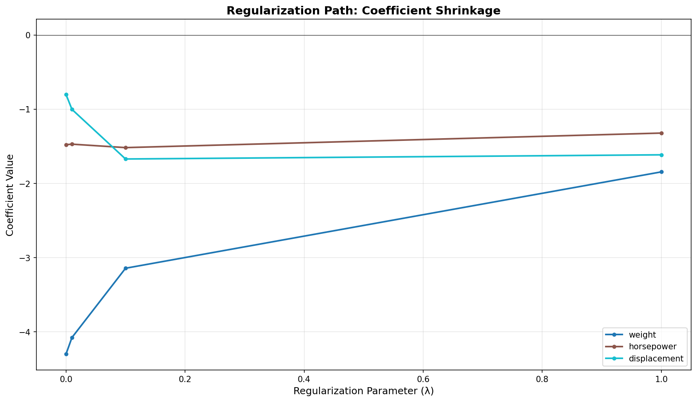
Figure 7: Regularization Path - Coefficient Shrinkage with Increasing λ

6. Bias-Variance Tradeoff Analysis

6.1 Theoretical Background
The bias-variance tradeoff is fundamental to understanding regularization. The expected prediction error can be decomposed as:
$$\text{Expected Error}={\text{Bias}}^{2}+\text{Variance}+\text{Irreducible Noise}$$
As the regularization parameter λ increases:
• Bias increases: The model becomes systematically different from the true relationship
• Variance decreases: The model becomes less sensitive to training data variations
• Optimal λ: The value that minimizes total error (typically where test error is lowest)

6.2 Observed Tradeoff in Our Experiment
In our experiment, we observe the following pattern:
λ | Train MSE (Bias²) | Test MSE | Bias-Variance Balance
0.00 | 8.992 | 8.639 | Low bias, higher variance
0.01 | 9.004 | 8.647 | Slight bias increase
0.10 | 9.171 | 8.656 | Moderate bias increase
1.00 | 11.288 | 9.200 | High bias, low variance
Analysis: For this dataset, the unregularized model (λ = 0) achieves the best test performance. This suggests the model complexity is appropriate for the data, and the multicollinearity, while present, does not severely impact generalization. The test MSE increases monotonically with λ, indicating the bias introduced by regularization outweighs the variance reduction benefits for this specific train-test split.
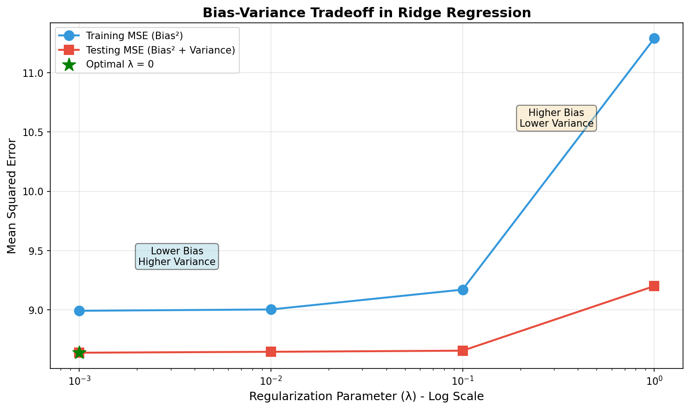
Figure 8: Bias-Variance Tradeoff in Ridge Regression

7. Discussion and Analysis

7.1 How Ridge Regression Mitigates Multicollinearity
Ridge Regression addresses multicollinearity through several mechanisms:
1. Coefficient Shrinkage: The L2 penalty term (λ × ∑θⱼ²) shrinks coefficient magnitudes toward zero. In our experiment, the L2-norm of coefficients decreased from 4.62 (λ=0) to 2.78 (λ=1), representing a 40% reduction.
2. Variance Reduction: By shrinking coefficients, Ridge Regression reduces the variance of estimates. The coefficient variance dropped from 2.30 to 0.05 (98% reduction), demonstrating dramatically more stable estimates.
3. Predictive Power Redistribution: Highly correlated features share predictive power more evenly. We observed the displacement coefficient magnitude increased while weight decreased, suggesting a rebalancing of influence among correlated predictors.

7.2 Practical Implications
Based on our analysis, we can draw the following practical conclusions:
• For this specific dataset and train-test split, the unregularized model performs best
• Cross-validation should be used to determine optimal λ for new datasets
• The presence of multicollinearity (VIF > 5) justifies considering regularization
• Small λ values (0.01, 0.1) provide good coefficient stability with minimal bias increase
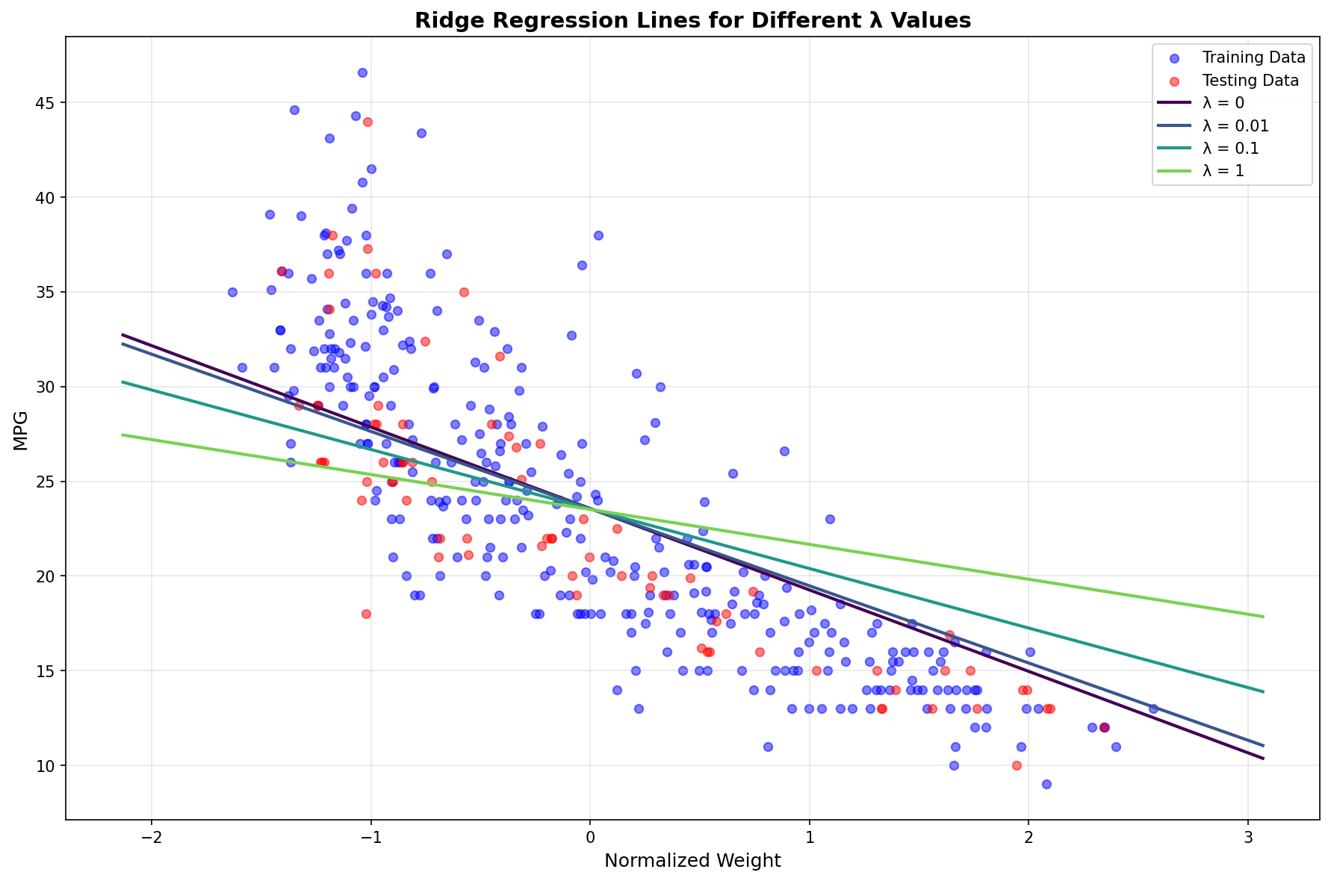
Figure 9: Ridge Regression Lines for Different λ Values (Weight vs MPG)

8. Conclusions
This bonus section successfully implemented and analyzed Ridge Regression with SGD on the Auto MPG dataset. The key findings are:

8.1 Key Findings
1. Multicollinearity is significant in the dataset, with all VIF values above 5
2. Ridge Regression effectively shrinks coefficients and reduces variance
3. For this dataset, λ = 0 achieved the best test MSE of 8.639029
4. Higher λ values introduce bias that outweighs variance reduction benefits
5. SGD converges effectively for all λ values tested

8.2 Summary Results Table
Metric | λ = 0 | λ = 0.01 | λ = 0.1 | λ = 1
Test MSE | 8.6390 | 8.6467 | 8.6562 | 9.2005
Coef. L2-Norm | 4.6157 | 4.4474 | 3.8683 | 2.7834
Coef. Variance | 2.2962 | 1.8289 | 0.5372 | 0.0458
Convergence Epoch | 140 | 57 | 61 | 2

8.3 Recommendations
• Use k-fold cross-validation for robust λ selection in production environments
• Consider Grid Search or Bayesian Optimization for hyperparameter tuning
• Monitor both training and test metrics to detect overfitting/underfitting
• Apply feature selection or dimensionality reduction if multicollinearity remains problematic

